# Problem 3. JS Courses

Use the **index.html** and **app.js** files to solve this problem. You have **NO permission** to directly change the given HTML code (index.html file).

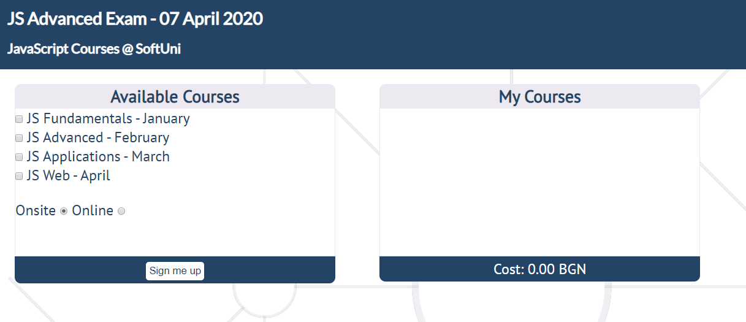

### Your Task

**Write the missing JavaScript code** to make the **planning for the next season of SoftUni** **Courses functionality** work as follows:

This season **SoftUni** has focused solely on JS courses. That’s awesome, right? **The** **available** **courses** are:

* **JS Fundamentals** – 170 BGN
* **JS Advanced** - 180 BGN
* **JS Applications** - 190 BGN
* **JS Web** - 490 BGN

The offered **education forms** are **Onsite** and **Online.**

The **JS Fundamentals, JS Advanced** and **JS Application** courses form a whole **Module.**

Fortunately, there are some cases where students receive a **discount**:

* If **JS Advanced** is combined with **JS Fundamentals,** the student receives a **10% discount** on **JS Advanced.**
* If **all three** courses are selected (JS Fundamentals, JS Advanced and JS Applications), students receive a **module discount** - **6%** on the module's **total price**.
* If **all available courses** are selected, students get a **bonus** **course** - '**HTML** **and** **CSS**'.
* Students also get a **discount** if their **education** **form** is **online** - **6% on all courses.**

You need to **CCC**:

* **Check** which **courses** and **education** **form** are selected.
* **Create** a **list item** for every **course** and append it to the given **unordered** **list.**
* **Calculate** the **total price** of **all courses** the student has signed up for and **update** the **cost.**

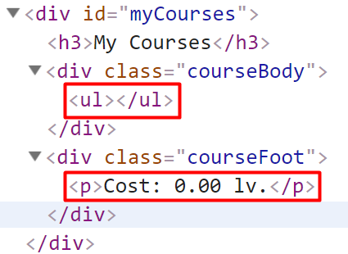

## **Example:**



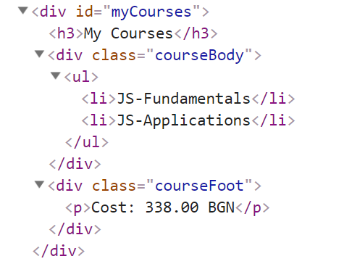

### Hint

* A student can receive **more than one discount.**
* **The courses’ cost** needs to be rounded to the **closest integer,** followed by **two zeros**.

### Submission

Submit your solution into a function.

